Wharncliffe Chase Geocross V40 Revision C 3 Mar 2021

Each of the locations can be found on the route below. The locations are listed in order and sufficient background is included to help you triangulate your position to identify the location.

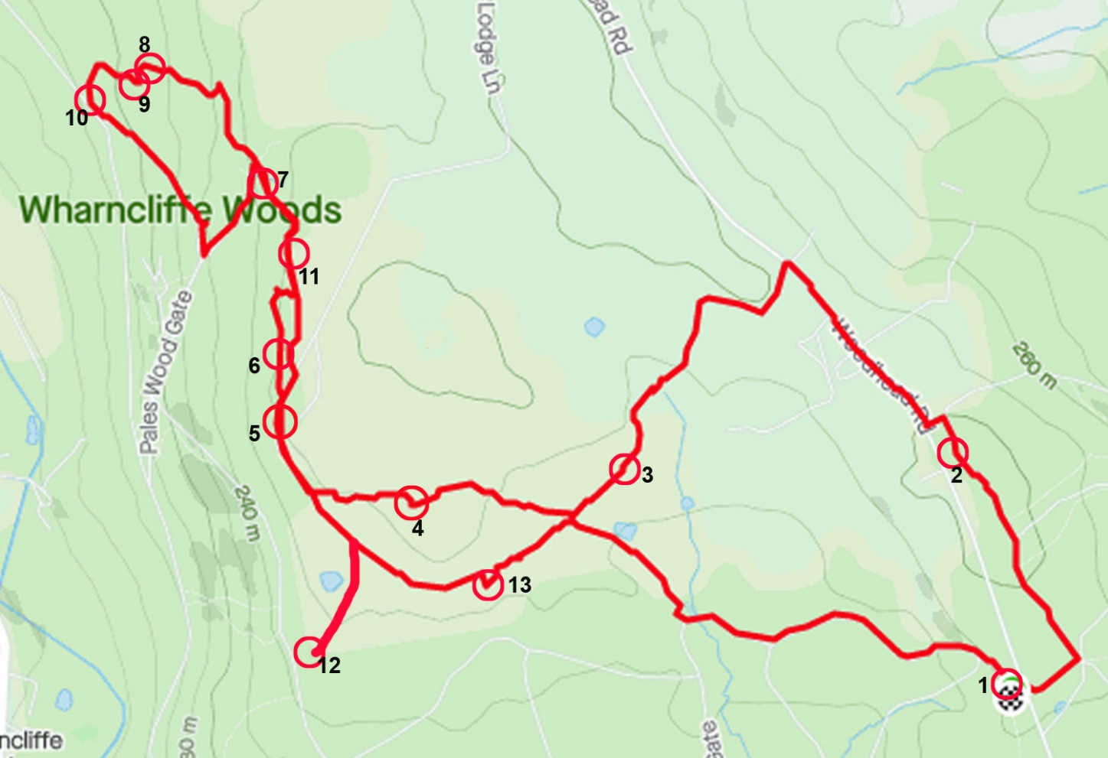
Start at Wheata Wood car park on Woodhead Road

Location 1 OS ref SK 32498 94998
Wheata Woods car park sign
Contains “plank”
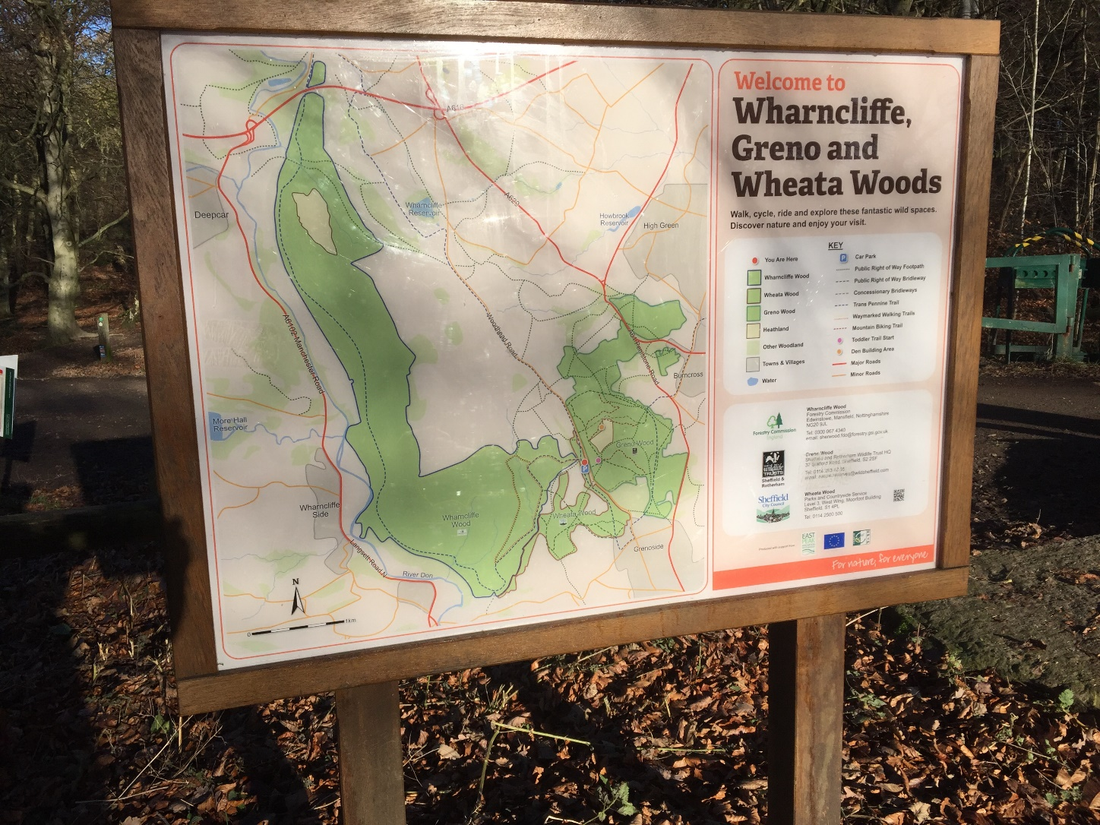
Wharncliffe, Greno and Wheata Woods are the premier mountain biking destination in Sheffield. The woods are managed by the Forestry Commission and Sheffield City Council. Mountain bikers have been active here for 30 years or so, and have recently taken the opportunity to help develop trails of all difficulties.
It is a great achievement that walkers, horse riders, runners and mountain bikers can get on so well. Most encounters are cheery. Be Nice, Say Hi!

Location 2 OS ref SK 32359 95615
Greno Knoll trig
Contains “frozen”
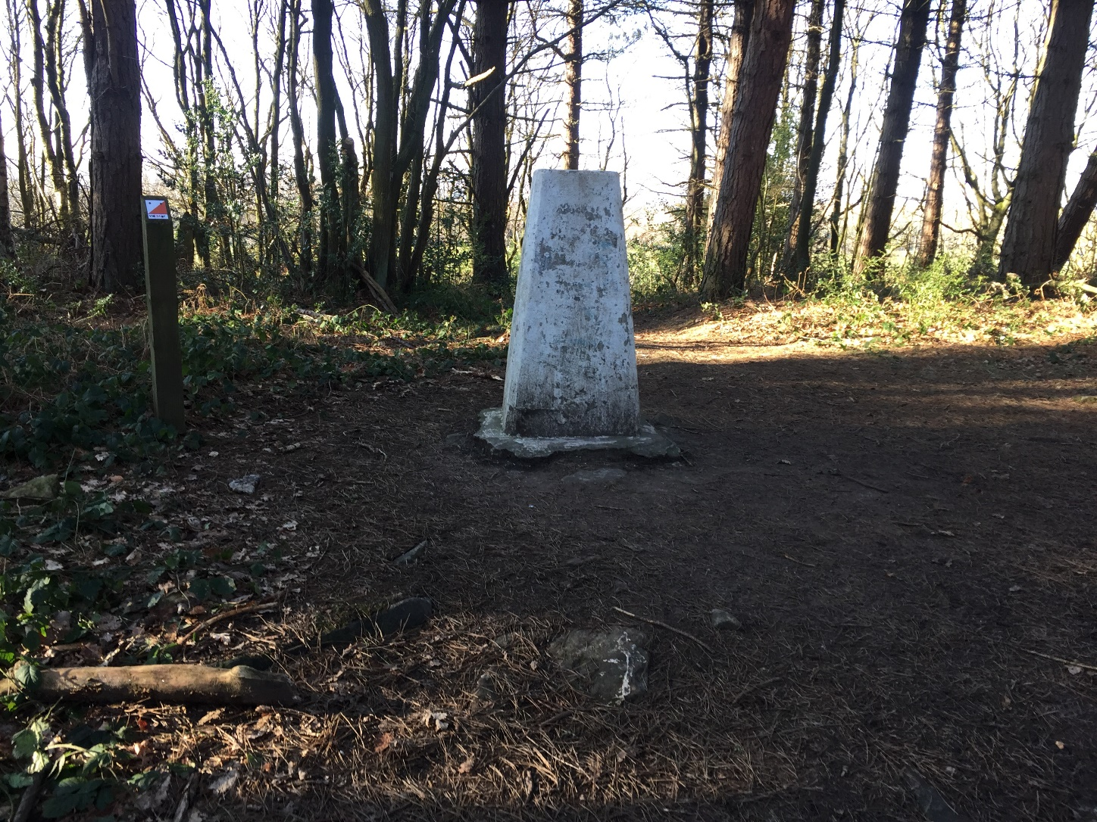
A shared trail leads to Greno Knoll. Look for the unique trails nearby that are just for expert mountain bikers. You wouldn’t want to walk on them!

Location 3 OS ref SK 31347 95431
Boundary marker posts
Contains “covers”
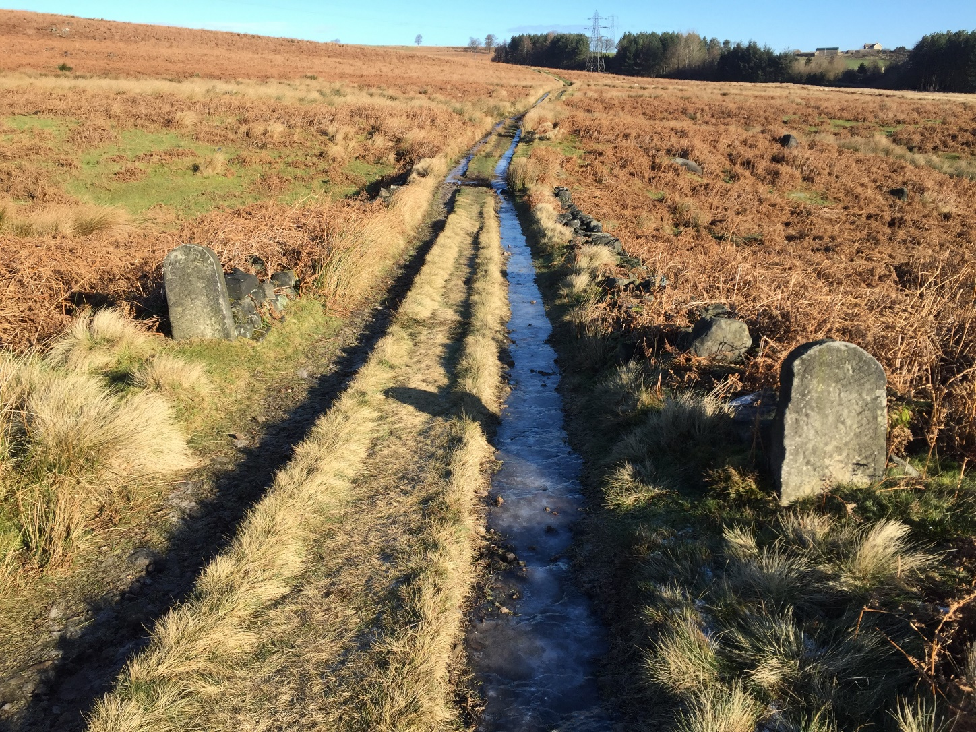
Wharncliffe Chase is a large expance of moorland and once a royal deer-hunting park. Now grazed by sheep.
These short carved posts are clearly not gate posts as they are not opposite each other.

Location 4 OS ref SK 30913 95467
Hobb Stones - centre
Contains “edits”
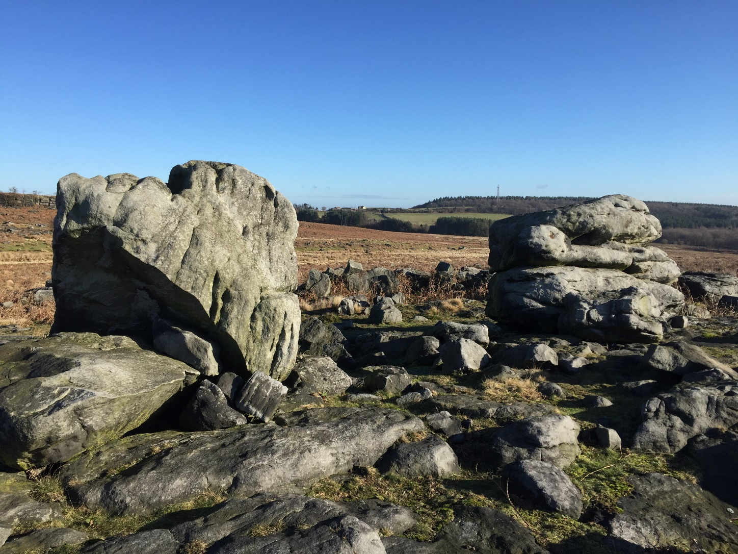
Brownlow Rocher may be the crag in the left background, the highest point on Wharncliffe Chase. Such a striking gritstone edge deserves a name. Rocher fits it well and it is similar to nearby Agden Rocher.
The Hobb Stones are a distinctive pair of boulders on a lesser high point.
The OS map labelling for these locations is not well placed.

Location 5 OS ref SK 30537 95637
Wharncliffe Lodge – bench at NW corner
Contains “evenly”
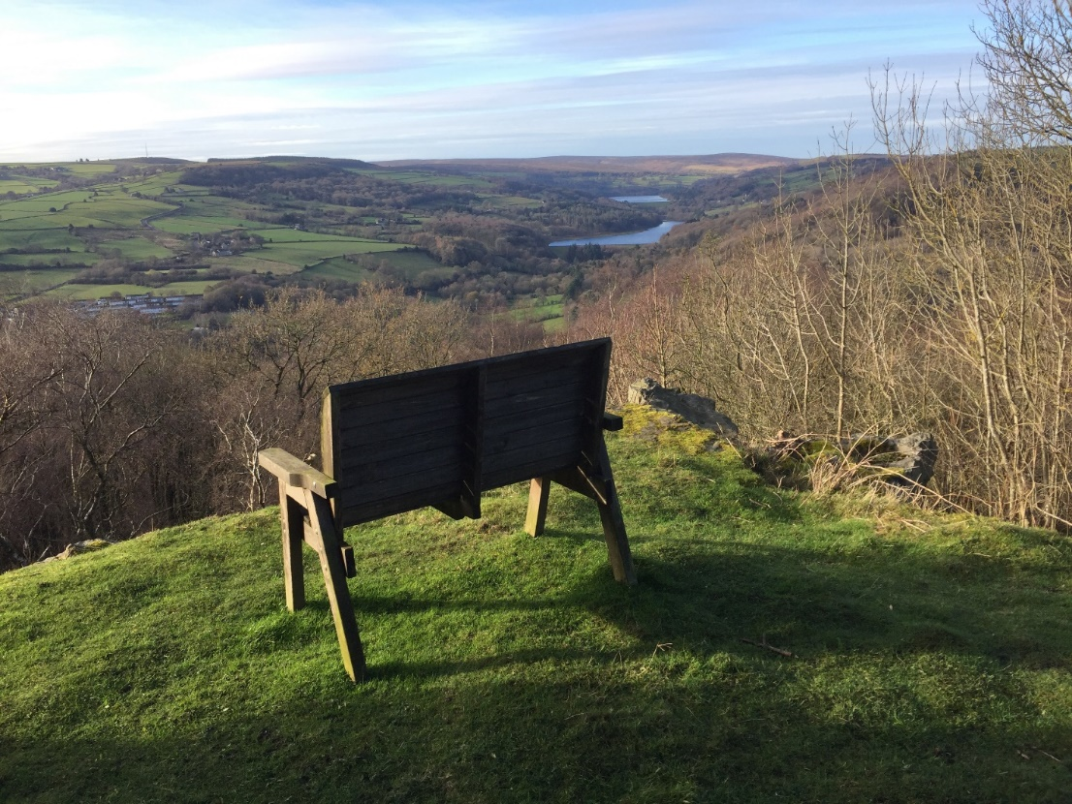
At the south of Wharncliff Edge is Wharncliffe Lodge, a farm with outbuildings positioned on the edge of a steep escarpment with an extensive view west over the Ewden Valley. This was the home of the Earls of Wharncliffe.
The original lodge was built in 1510. The present day lodge is the third building on the site and was erected in the 19th century. It has more of the appearance of a solid working moorland farmhouse rather than a ‘lodge’ on a royal deer hunting park.
Lady Mary Wortley Montagu resided there for short periods in the early 1700s.
Wharncliffe Chase was a royal hunting park in the medieval period. At the end of the 16th century, Sir Richard Wortley was Earl of Wharncliffe. To raise his status he rebuilt and enlarged his stately house, Wortley Hall, and expanded his private hunting estate on Wharncliffe Chase. This involved evicting the inhabitants of two small villages. Protests against his actions included poaching his deer, which was traditional, and the writing of a parody ballad which was brilliant. The commoners nick-named their lord the Dragon of ‘Wantley’, a word-play on his proper title Wortley. The pen is mightier than the sword.
The Ballad of the Wantley Dragon has a heroic knight, ‘More of More Hall’, tricking the dragon. The dragon couldn’t be killed by a man, so the knight put spikes on his armour and allowed the dragon to encircle him, squeezing itself onto the spikes and thereby killing itself. The ballad legend made this the most famous dragon in England and earned it’s place in literature, being named the Dragon of Wantley in the first paragraph of Sir Walter Scott’s Ivanhoe.
Location 6 OS ref SK 30576 95866
Dragons Den
Contains “screeches”
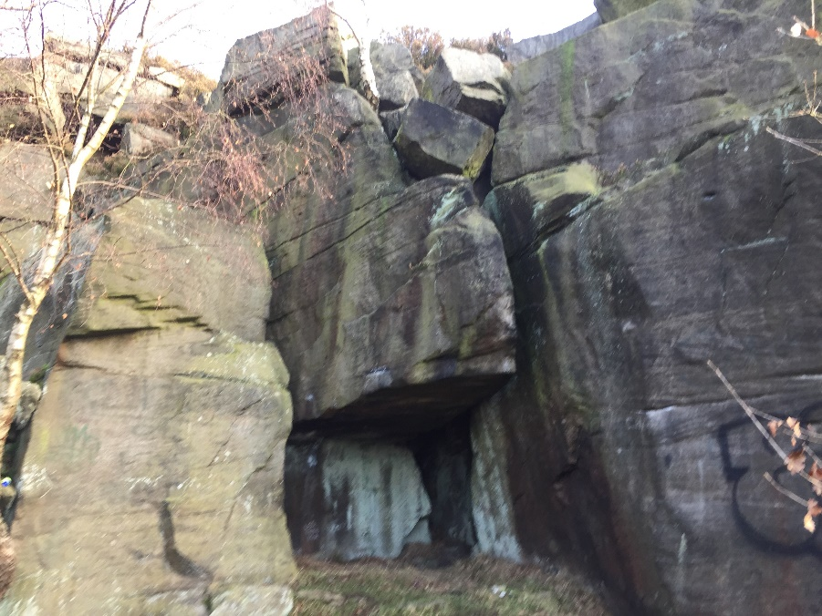
The Dragon’s Den is 200 metres north of the Wharncliffe Lodge, reached by a quarry track below the crags. Climbers know this as ‘Lodge Buttress’ and call it ‘Dragons Cave’. Further north are a succession of other buttresses with many caves, all suitable for dragons. Lady Wharncliffe’s Road is above the crag.
Wharncliffe Edge is a 2.5km long gritstone edge overlooking the Upper River Don. It is one of the most accessible gritstone outcrops and attracted early pioneers including JW Puttrell who climbed there from 1885, initially climbing solo and later introducing his friends to take up this new activity. This was the birthplace of gritstone climbing with 100 routes by 1900.
In earlier centuries the edge was extensively quarried, notably for quern stones. Recent summer fires exposed over 2300 of them lying in situ at the quarry sites. The quern production site is a Scheduled Ancient Monument. Quern stones were hand tools used in pairs for grinding grain, later replaced by water-powered millstones.

Location 7 OS ref SK 30511 96334 (may be inaccurate due to trees)
Dragon’s Well
Contains “printout”
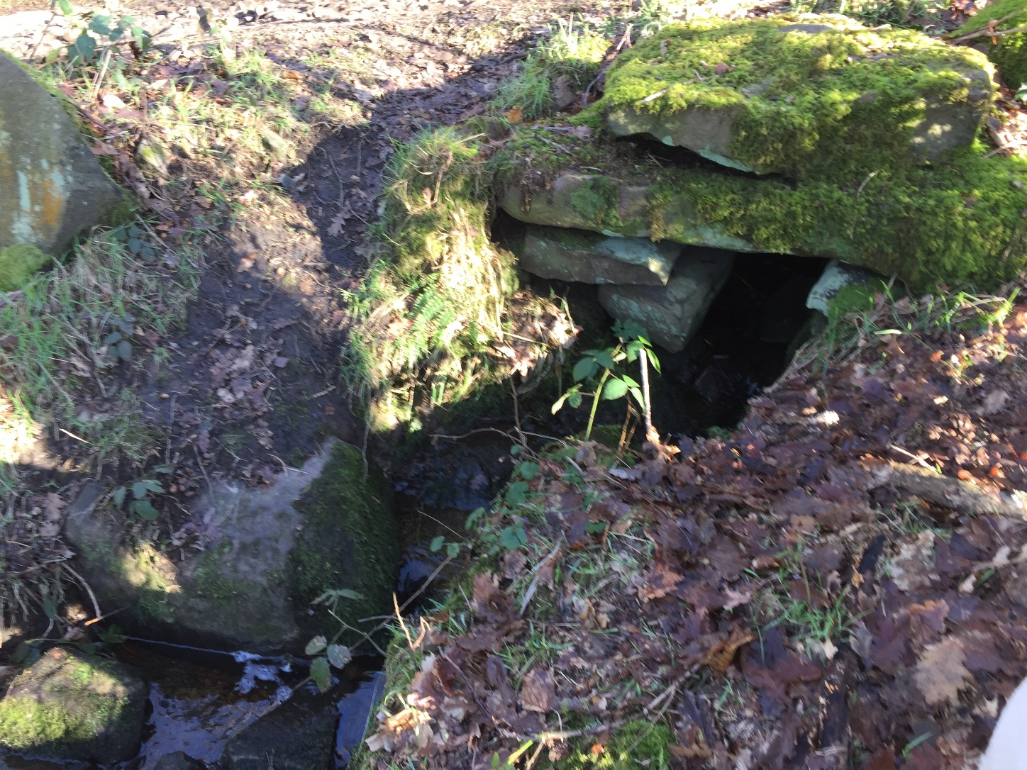
The nearest water to the named ‘Dragons Well’ on the OS map.
This small stream passes beneath Lady Wharncliffe’s Road 400 metres north of Dragon’s Den. It is the closest source of running water to Wharncliffe Lodge.

Location 8 OS ref SK 30180 96700 (may be inaccurate due to trees)
Gannister valley – low point where MTB track crosses
Contains “jokes”
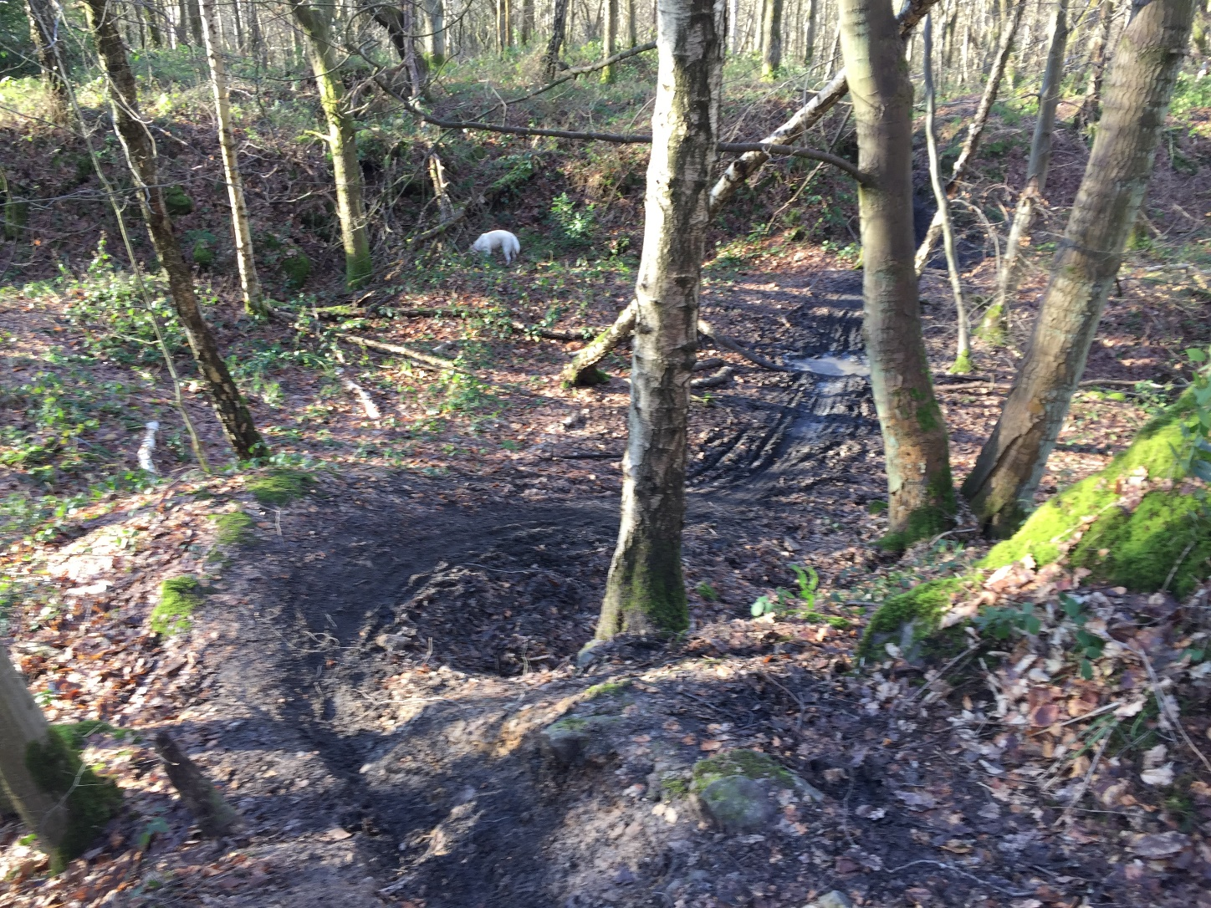
Gannister was mined extensively in the Upper Don Valley, and in the Loxley and Stannington area..
The escarpment below Wharncliffe Crags had been quarried for stone, clay and coal on a small scale for hundreds of years. This moved up to an industrial scale in the late 1800s when there was a high demand for gannister clay, used for fire resistant refractory bricks which were needed to line Sheffields’s steel furnaces. The gannister mines made a huge impact on the landscape. This massive trench is up to 10 metres deep and cuts a 700 metre long valley below Wharncliff Upper Crag. It was mined by open-cast workings which form a small valley, making it easier to extract the gannister.
By the 1930’s there were three large refractory brick manufacturers in the Loxley Valley, supplying 95% of Britains needs for furnace lining bricks. The gannister workings were abandoned when the industry collapsed in the 1980s due to a lack of demand.

Location 9 OS ref SK 30181 96587
Gannister mine – south wall end
Contains “revives”
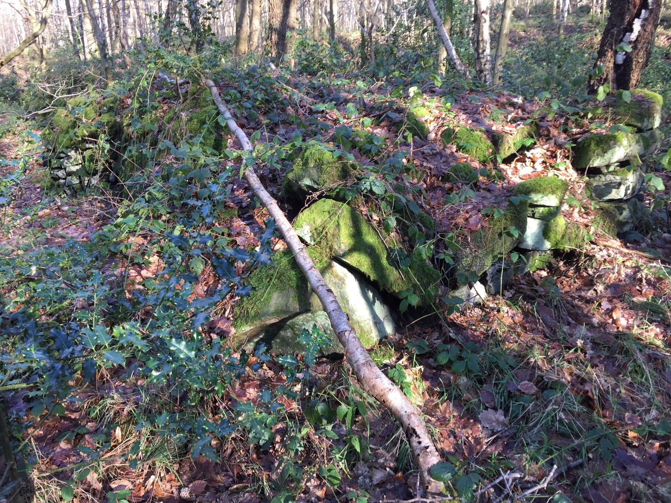
The OS map names a mine. It is probably a gannister mine. This is a wide stone wall beneath which may be a continuation of the open-cast gannister mine to the north.

Location 10 OS ref SK 30059 96508
Trans Pennine Trail – Sheffield sign
Contains “extensive”
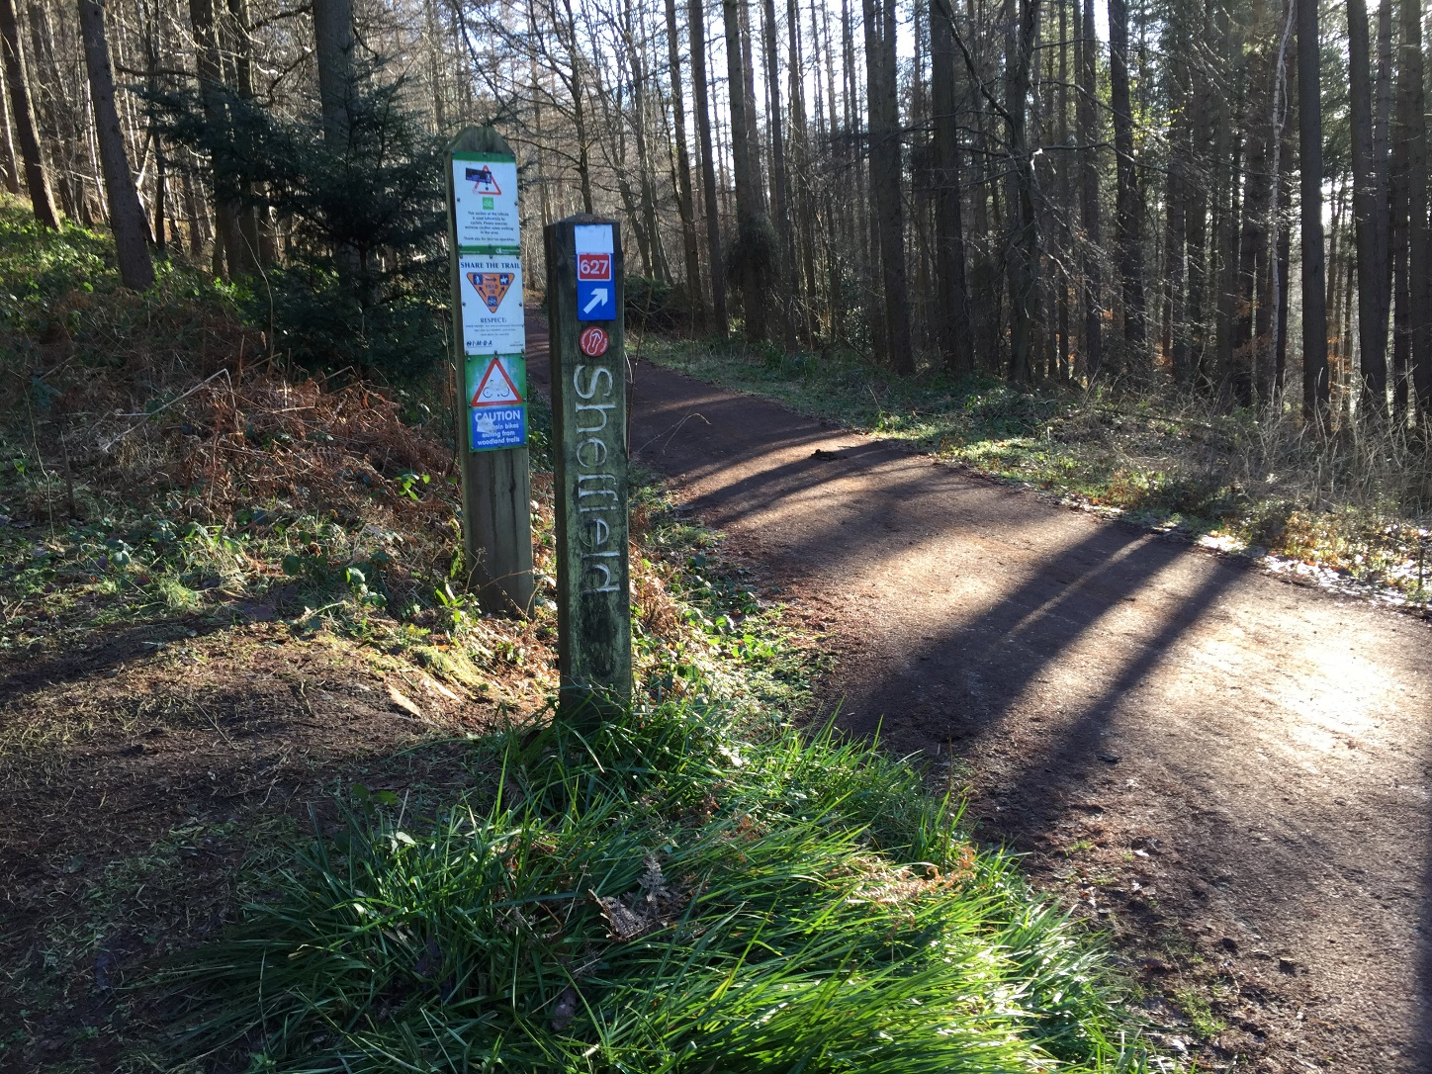
The Trans Pennine Trail (TPT) is a long distance bridleway for walkers, cyclists and horse riders, travelling 346 km linking the North Sea to the Irish Sea. It is well signposted and has easy gradients and surfaced paths. Access points usually have car parks.
The TPT links existing footpaths, canal paths and old railway lines.
This part follows Plank Gate, an old footpath linking Stocksbridge to Oughtibridge.

Location 11 OS ref SK 30582 95868
Trough
Contains “beaks”
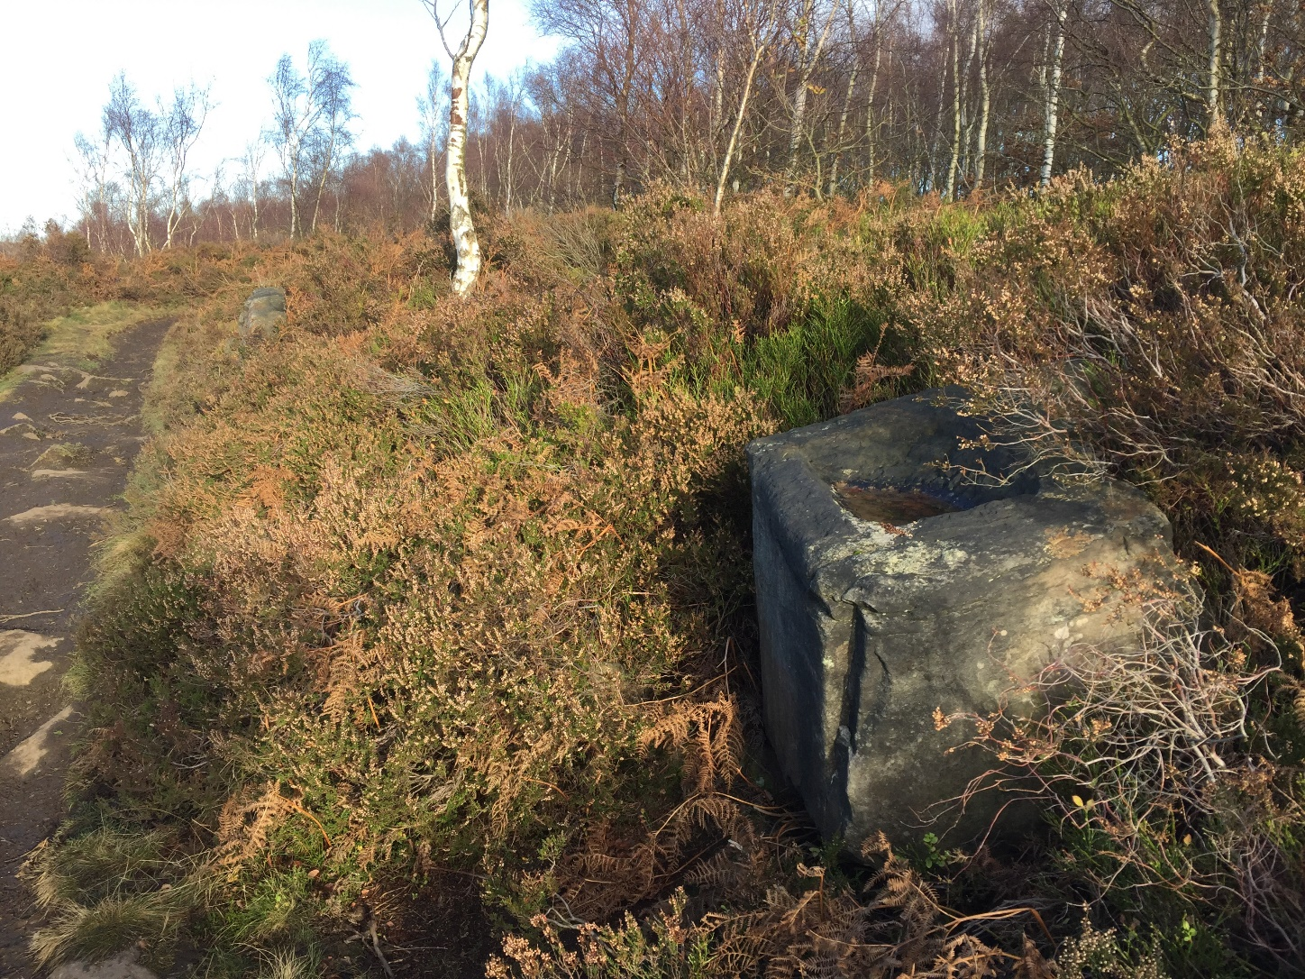
Shallow trough. Either for dragon or horse drinking. Possibly for workmen to sharpen quarrying tools.
The Dragons Den is just below.

Location 12 OS ref SK 30668 95017
Old Yew Gate
Contains “scam”

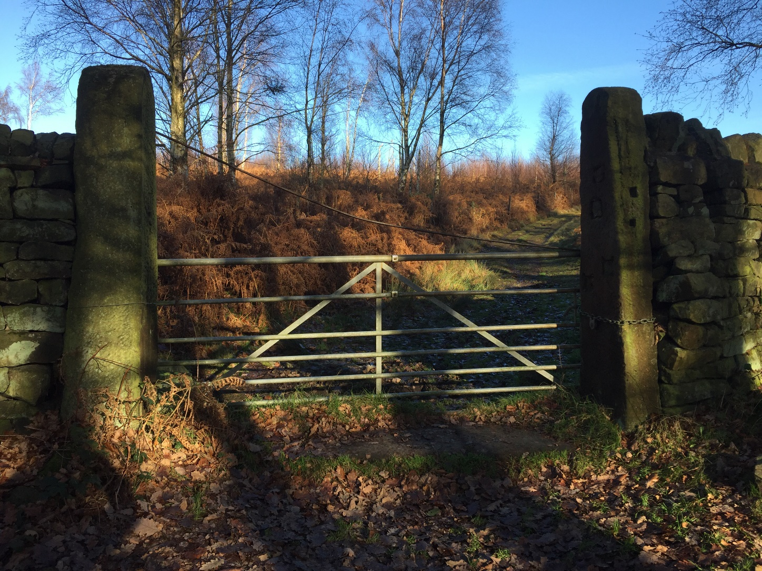
One of several tall gated access points to the deer-park of Loxley Chase. In the days of deer-hunting the gates and walls would have been taller. This wall is 1.8 metres high but the modern gate is 1.2 metres.

Location 13 OS ref SK 31113 95253
Stone shooting butt
Contains “jumped”
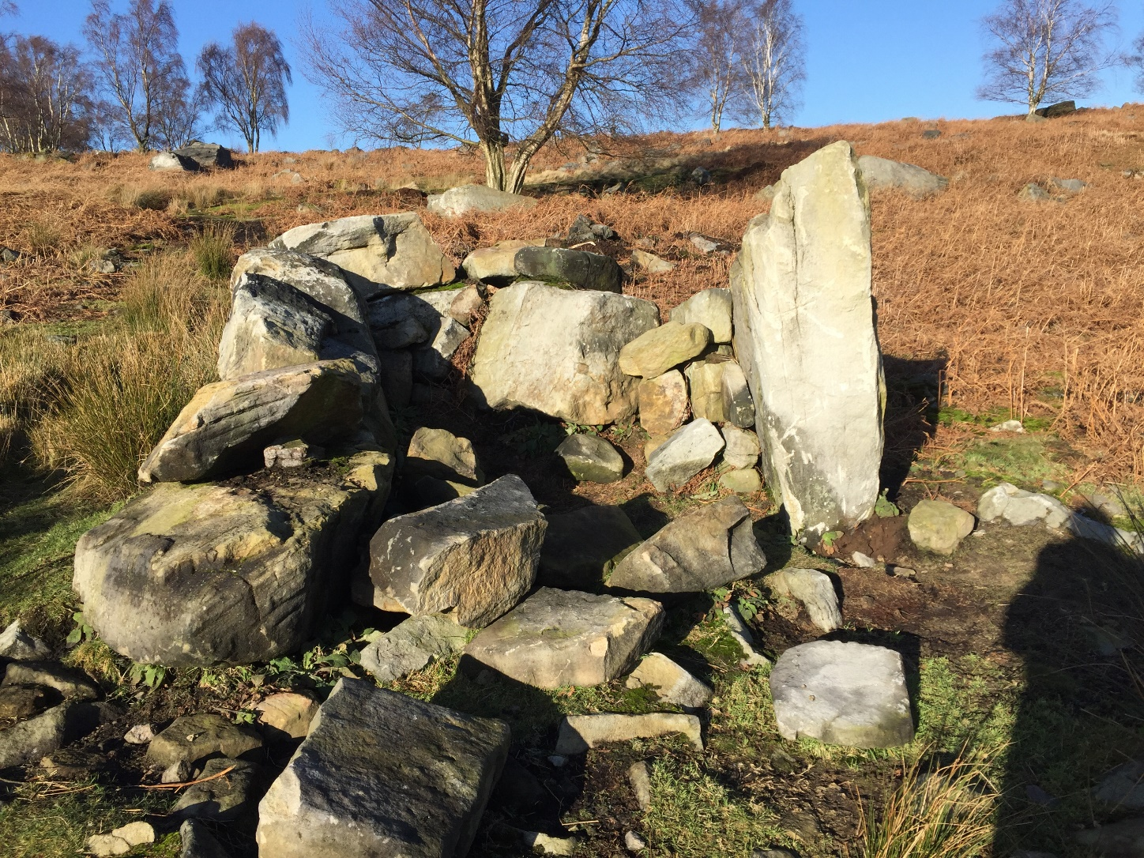
One of a line of 8 shooting butts below the track leading to Wharncliffe Lodge. Not so much ‘built’ but ‘assembled’ by a large earthshifting machine using massive boulders gathered from the surrounding Moor. More like a megalithic monument than a shooting butt.
Fred Flintstone would have been proud of the workmanship.
They appear to have been thrown together within the past 3 years.

